Curriculum Vitae

Name : W.A Sachiththa Bhathiya Wickramarachchi 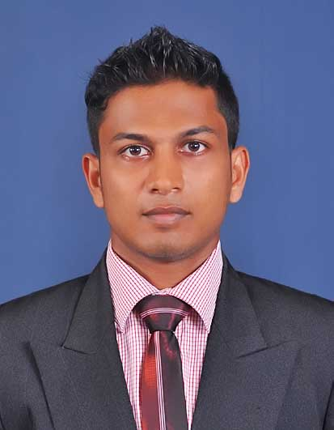
Address : No 462,C Maharanugegoda,Kadawatha
E-mail : Bhathiya0102@gmail.com
Date of Birth : 02 - 01 - 1990
Gender : Male
Tel Residence : 0112921216
Mobile : 071 – 6419801

Career Objective

I ensure to enroll with my fullest strength, dedication & enthusiasm to gain all-round knowledge and experience while contributing to the organization’s success.
Personal Profile

As a young dynamic person, I consider self confidence & dedication are as my greatest strengths.
I am capable of shouldering responsibilities and punctuality is the basis of my success.
Training and Job Experience

- Completed my 6 months industrial training at hambanthota main office of Maga Engineering (Pvt) Ltd.(circle roads of mirijjawila)
- I have one year experience As an assistant Quantity surveyor in KES engineering (PVT)Ltd.

- General QS experience
- Taking off quantities

- Preparing bar schedules

- Preparing and checking Interim payments

- Preparing sub bills

- Site experience
- Labour handling for civil work.
- Monitoring the balance work and balance material at the site.
- Reinforcement works
- Form work & concrete works of the culvert and bridges

Educational Qualifications

- B.Sc. (Hons) Quantity Surveying & Construction Management
Sheffield Hallam University, UK
Affiliated by ICBT Campus (International College of Business and technology) – Mount Lavinia, Sri Lanka.

- HND in Quantity Survey
ICBT Campus
Mount Lavinia

- School Attended : Bandaranayake college,Gampaha
- G.C.E (A/L) in 2008 : Studied in Mathematics stream
- G.C.E. Ordinary Level Examination in 2005

Research carried out

- Research on “STUDY OF ROAD CONSTRUCTION PROJECTS TO DECREASE THE COST OF MAJOR ITEMS” in ICBT campus, Mount Lavinia

Key Skills

- Fluency in Sinhala & English Languages
- IT skills (Word, excel, PowerPoint, email & internet)
- Skill in auto cad
- Enjoys being part of a successful and productive works in highly pressurized and challenging working environments
- Presentation & Communication skills
- Excellent team worker

Extra Curricular Activities

- Member of school cricket team
- Participated in inter school cricket tournament.
- Participated in athletic events.
- Participated in English day competitions at school.
- Member of the Science and Mathematics club of bandaranayake college (2007/08)
- Passed the Certificate level in CIT course in Esoft.
- Followed an English diploma in royal institute

Interests

- Cricket, volley ball, Foot ball
- Listening to music.
- Dancing.
- Reading news papers
- Online gaming

Non-Related Referees

Mr. J.L.T Dinesh

Senior Quantity surveyor
Main office,
Maga Engineering (Pvt) Ltd
Mirijjawila,
Hambanthota.

Tel : 0772014083

Mr. Gamini Rajakaruna
Head of Faculty (Engineering & Construction,
ICBT Mount Campus,
Mount Lavinia,

Tel : 0777442691

I do hereby declare that the above particulars furnished by me are true and accurate to the best of my knowledge.

……………………………..
W.A.S.B Wickramarachchi Date: 01/06/2015

